**Experiment-4**

Residence Time Distribution in a

Tubular Vessel

*18CH10071, Anshuman Agrawal*

**Objectives**

1. To construct C curve for pulse input
2. To plot age-distribution curve (E vs t)
3. To calculate average residence time
4. To calculate vessel dispersion number (D/ uL) for 3 different flow rates

**Theory**

The Residence Time Distribution (RTD) is used to determine the deviation from ideal flow patterns in a real reactor. It is also used as an effective diagnostic tool to inspect any possible malfunction in the reactor. The dimensionless form of Fick’s second law with z = x/L and ϴ = t/ t**.** = tu/ L is as follows:

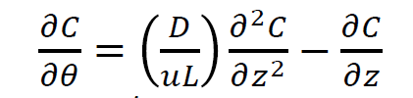

Here, D/ uL is the vessel dispersion number and is the parameter which measures the extent of axial dispersion.

When D/ uL → 0, negligible dispersion occurring and plug flow occurs.

When D/ uL → ꝏ, large amount of dispersion takes place and mixed flow occurs.

For a closed vessel, the parameter D/ uL is calculated from the following:

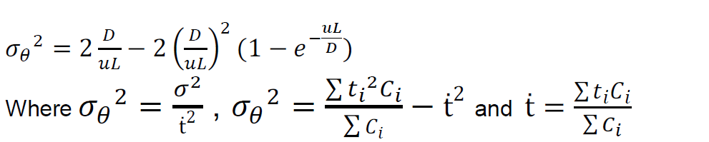

**Schematic**

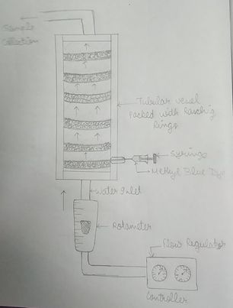

**Observations and Calculations**

Length of tubular reactor (L) = 81.5 cm

ID of the tube (d) = 5 cm

*Since concentration is directly proportional to absorbance, they can be used interchangeably.

|  |  |  |  |  |  |  |
| --- | --- | --- | --- | --- | --- | --- |
| **Flow rate: 10 LPH** | | | | | | |
| **Time ti (min)** | **Absorbance (Concentration Ci)** | **Ei = Ci/Area under C-curve** | **tiCi** | **ti^2** | **(ti^2)Ci** | **Area** |
| 1 | 0.006 | 0.00476002 | 0.006 | 1 | 0.006 | - |
| 2 | 0.014 | 0.0111067 | 0.028 | 4 | 0.056 | 0.01 |
| 3 | 0.016 | 0.01269338 | 0.048 | 9 | 0.144 | 0.015 |
| 4 | 0.018 | 0.01428005 | 0.072 | 16 | 0.288 | 0.017 |
| 5 | 0.026 | 0.02062674 | 0.13 | 25 | 0.65 | 0.022 |
| 6 | 0.115 | 0.09123364 | 0.69 | 36 | 4.14 | 0.0705 |
| 7 | 0.203 | 0.1610472 | 1.421 | 49 | 9.947 | 0.159 |
| 8 | 0.225 | 0.1785006 | 1.8 | 64 | 14.4 | 0.214 |
| 9 | 0.195 | 0.15470052 | 1.755 | 81 | 15.795 | 0.21 |
| 10 | 0.159 | 0.12614042 | 1.59 | 100 | 15.9 | 0.177 |
| 11 | 0.132 | 0.10472035 | 1.452 | 121 | 15.972 | 0.1455 |
| 12 | 0.113 | 0.08964697 | 1.356 | 144 | 16.272 | 0.1225 |
| 13 | 0.083 | 0.06584689 | 1.079 | 169 | 14.027 | 0.098 |
| **sum (Ci)** | 1.305 | **sum (tiCi)** | 11.427 | **sum ((ti^2)Ci)** | 107.597 |  |
| **Area under C-curve** | | | | | | 1.2605 |

|  |  |  |  |  |  |  |
| --- | --- | --- | --- | --- | --- | --- |
| **Flow rate: 20 LPH** | | | | | | |
| **Time ti (min)** | **Absorbance (Concentration Ci)** | **Ei = Ci/Area under C-curve** | **tiCi** | **ti^2** | **(ti^2)Ci** | **Area** |
| 1 | 0.003 | 0.003674219 | 0.003 | 1 | 0.003 | - |
| 2 | 0.004 | 0.004898959 | 0.008 | 4 | 0.016 | 0.0035 |
| 3 | 0.006 | 0.007348438 | 0.018 | 9 | 0.054 | 0.005 |
| 4 | 0.028 | 0.034292713 | 0.112 | 16 | 0.448 | 0.017 |
| 5 | 0.175 | 0.214329455 | 0.875 | 25 | 4.375 | 0.1015 |
| 6 | 0.158 | 0.193508879 | 0.948 | 36 | 5.688 | 0.1665 |
| 7 | 0.113 | 0.138395591 | 0.791 | 49 | 5.537 | 0.1355 |
| 8 | 0.107 | 0.131047152 | 0.856 | 64 | 6.848 | 0.11 |
| 9 | 0.085 | 0.104102878 | 0.765 | 81 | 6.885 | 0.096 |
| 10 | 0.07 | 0.085731782 | 0.7 | 100 | 7 | 0.0775 |
| 11 | 0.058 | 0.071034905 | 0.638 | 121 | 7.018 | 0.064 |
| 12 | 0.008 | 0.009797918 | 0.096 | 144 | 1.152 | 0.033 |
| 13 | 0.006 | 0.007348438 | 0.078 | 169 | 1.014 | 0.007 |
| sum (Ci) | 0.821 | sum (tiCi) | 5.888 | sum ((ti^2)Ci) | 46.038 |  |
| Area under C-curve | | | | | | 0.8165 |

|  |  |  |  |  |  |  |
| --- | --- | --- | --- | --- | --- | --- |
| **Flow rate: 30 LPH** | | | | | | |
| **Time ti (min)** | **Absorbance (Concentration Ci)** | **Ei = Ci/Area under C-curve** | **tiCi** | **ti^2** | **(ti^2)Ci** | **Area** |
| 1 | 0.003 | 0.003674219 | 0.003 | 1 | 0.003 | - |
| 2 | 0.004 | 0.004898959 | 0.008 | 4 | 0.016 | 0.0035 |
| 3 | 0.006 | 0.007348438 | 0.018 | 9 | 0.054 | 0.005 |
| 4 | 0.028 | 0.034292713 | 0.112 | 16 | 0.448 | 0.017 |
| 5 | 0.175 | 0.214329455 | 0.875 | 25 | 4.375 | 0.1015 |
| 6 | 0.158 | 0.193508879 | 0.948 | 36 | 5.688 | 0.1665 |
| 7 | 0.113 | 0.138395591 | 0.791 | 49 | 5.537 | 0.1355 |
| 8 | 0.107 | 0.131047152 | 0.856 | 64 | 6.848 | 0.11 |
| 9 | 0.085 | 0.104102878 | 0.765 | 81 | 6.885 | 0.096 |
| 10 | 0.07 | 0.085731782 | 0.7 | 100 | 7 | 0.0775 |
| 11 | 0.058 | 0.071034905 | 0.638 | 121 | 7.018 | 0.064 |
| 12 | 0.008 | 0.009797918 | 0.096 | 144 | 1.152 | 0.033 |
| 13 | 0.006 | 0.007348438 | 0.078 | 169 | 1.014 | 0.007 |
| sum (Ci) | 0.821 | sum (tiCi) | 5.888 | sum ((ti^2)Ci) | 46.038 |  |
| Area under C-curve | | | | | | 0.8165 |

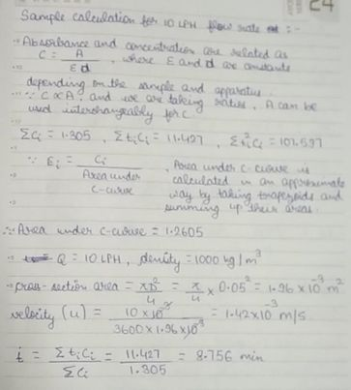

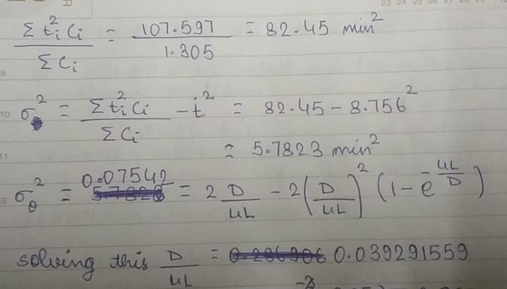

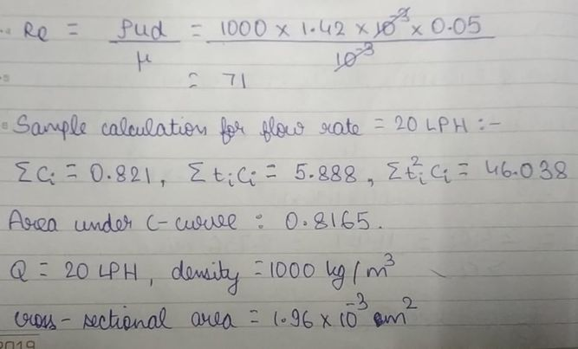

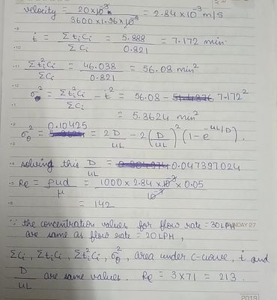

**Results**

|  |  |  |  |  |
| --- | --- | --- | --- | --- |
| **Flow Rate (LPH)** | **Velocity (m/s)** | **Reynold’s number** | **Average Residence Time t. (min)** | **D/uL** |
| 10 | 0.00142 | 71 | 8.756 | 0.039291559 |
| 20 | 0.00284 | 142 | 7.172 | 0.047397024 |
| 30 | 0.00426 | 213 | 7.172 | 0.047397024 |

**Plots**

**Discussion**

The probability that reactant molecules/ atoms undergo reaction inside a flow reactor is judged by the residence time distribution. There has been a certain measurement error while measuring absorbance for 20 LPH and 30 LPH flow rates because they are the exact same values. Although there is only slight change in the Reynold’s number, exactly same results are not expected to come up for different flow rates. The spectrophotometer was possibly not calibrated properly which might have resulted in such anomalous readings. We need to ensure that the sample is collected as much as possible, in exact 1-minute intervals because a few milliseconds here and there can cause erroneous measurements. The E-curve and C-curve for different flow rates are seen to have same shape due to them being related by a constant which is the area under the C-curve. The area under the C-curve is calculated by considering trapezoids formed by each segment of the plot. This will give an approximate estimation of the area and is probably the closest one can get to have minimum error. The flow rates for this experiment can be increased a bit to ensure more distinct results. Since we are dealing on the hour scale of flow rates, therefore a small change of 10 litres doesn’t create a very big difference as is evident from the D/uL vs Re plot.